**1) List of items added to the list.**

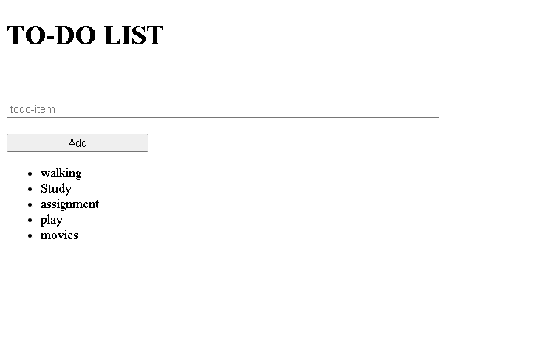

**2) You cannot add empty or null values to the list.**

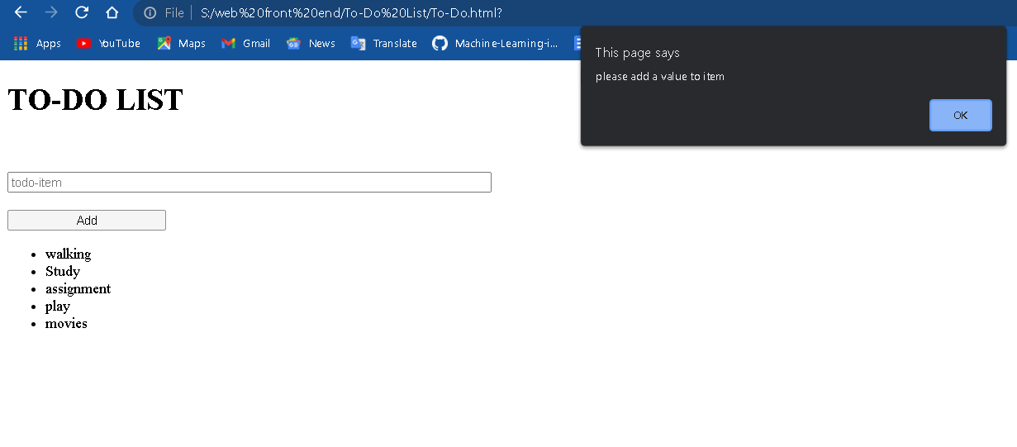

**3) You can delete a item with a click on any item.**

